1. Login your account

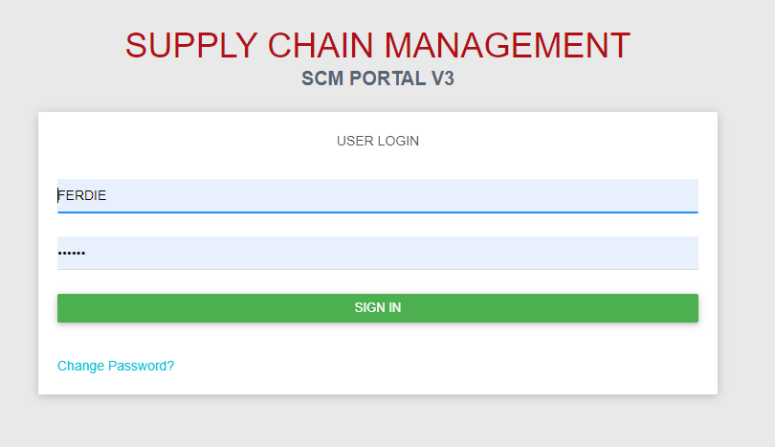

1. Maintenance Table – BCP Management Table (Insert and update table accordingly)

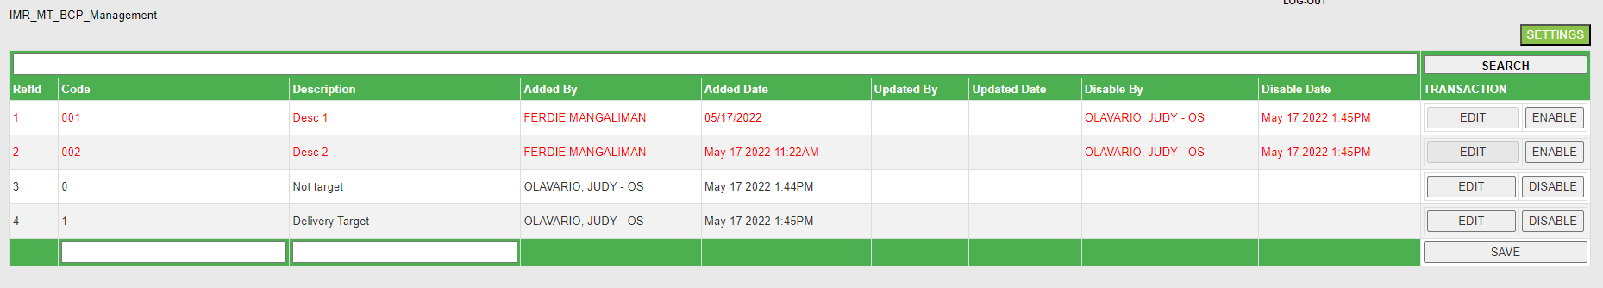

1. Maintenance Table - Asset Type (Insert and update table accordingly)

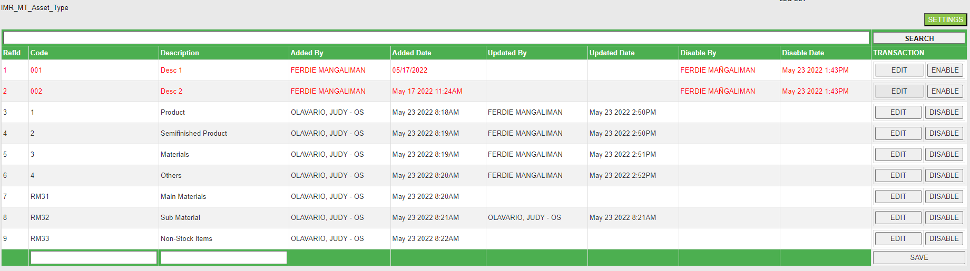

1. Maintenance Table – Auto Order Suspension (Insert and update table accordingly)

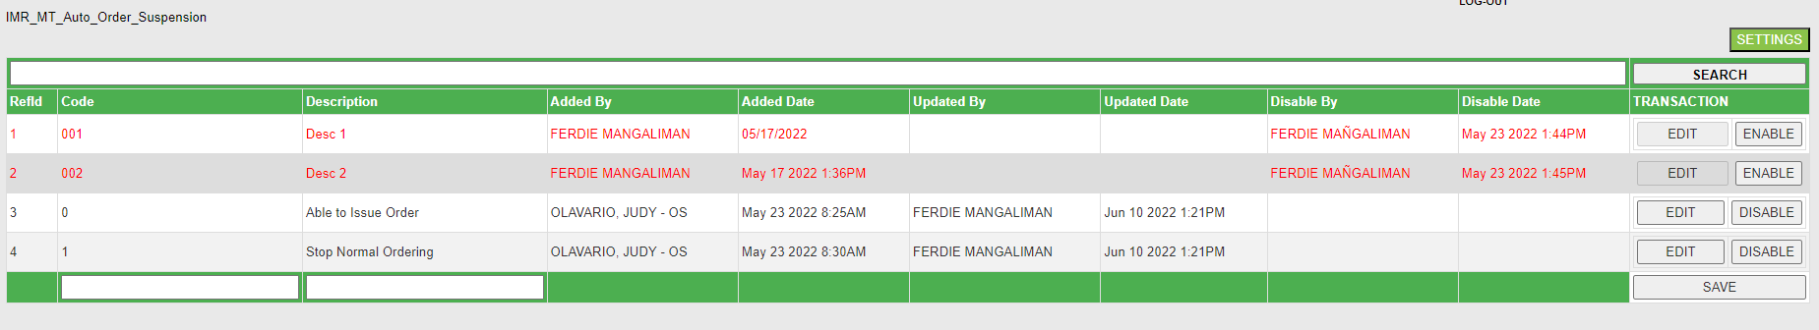

1. Maintenance Table – 3TG Table (Insert and update table accordingly)



1. Maintenance Table – Incoterms Table (Insert and update table accordingly)

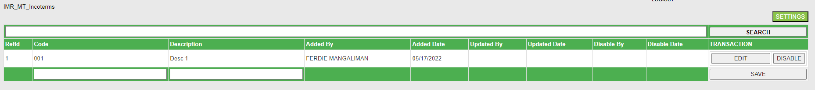

1. Maintenance Table – Tax Type (Insert and update table accordingly)

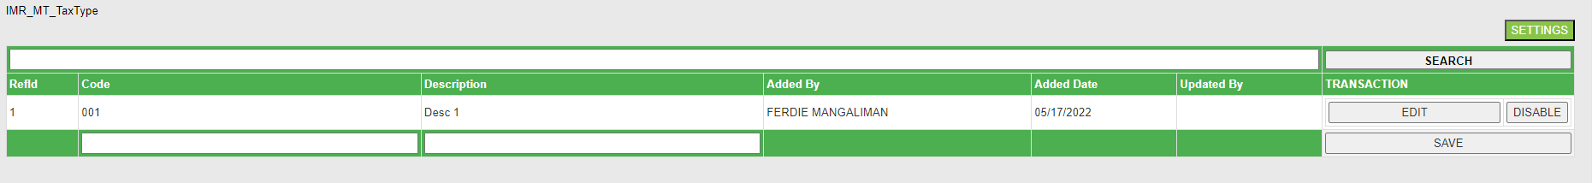

1. Maintenance Table – Remarks (Reason) (Insert and update table accordingly)

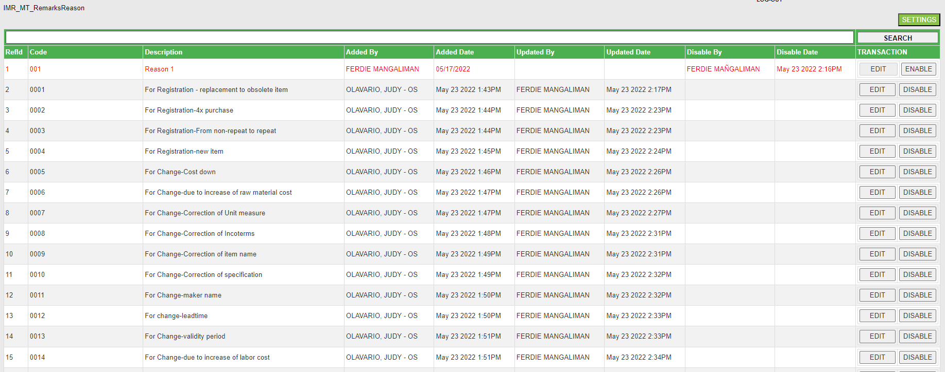

1. Maintenance Table – Item Class Code (Insert and update table accordingly)

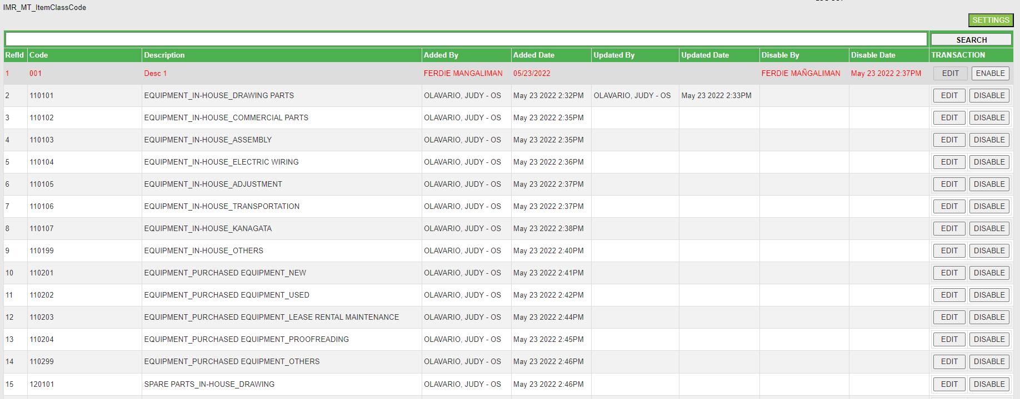

1. Maintenance Table – Quantity Unit (Insert and update table accordingly)

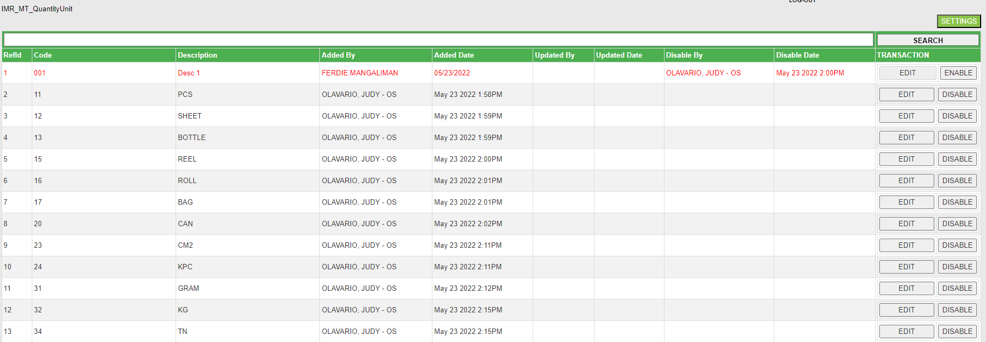

1. Maintenance Table – Business Type (Insert and update table accordingly)

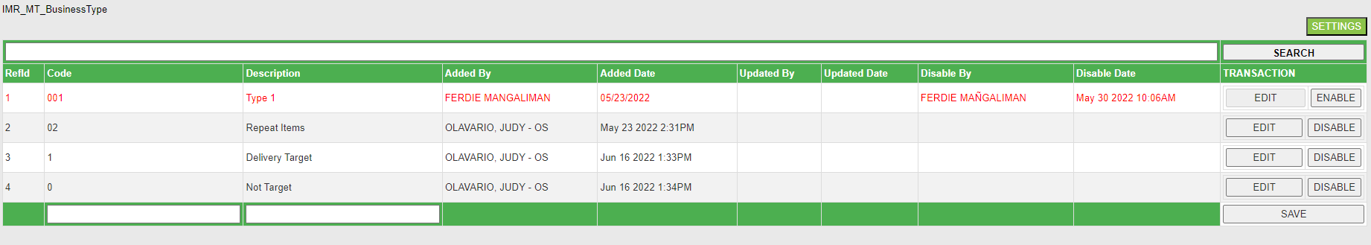

1. Transaction – Request Entry (Follow the instructions on how to insert new request or update existing request)

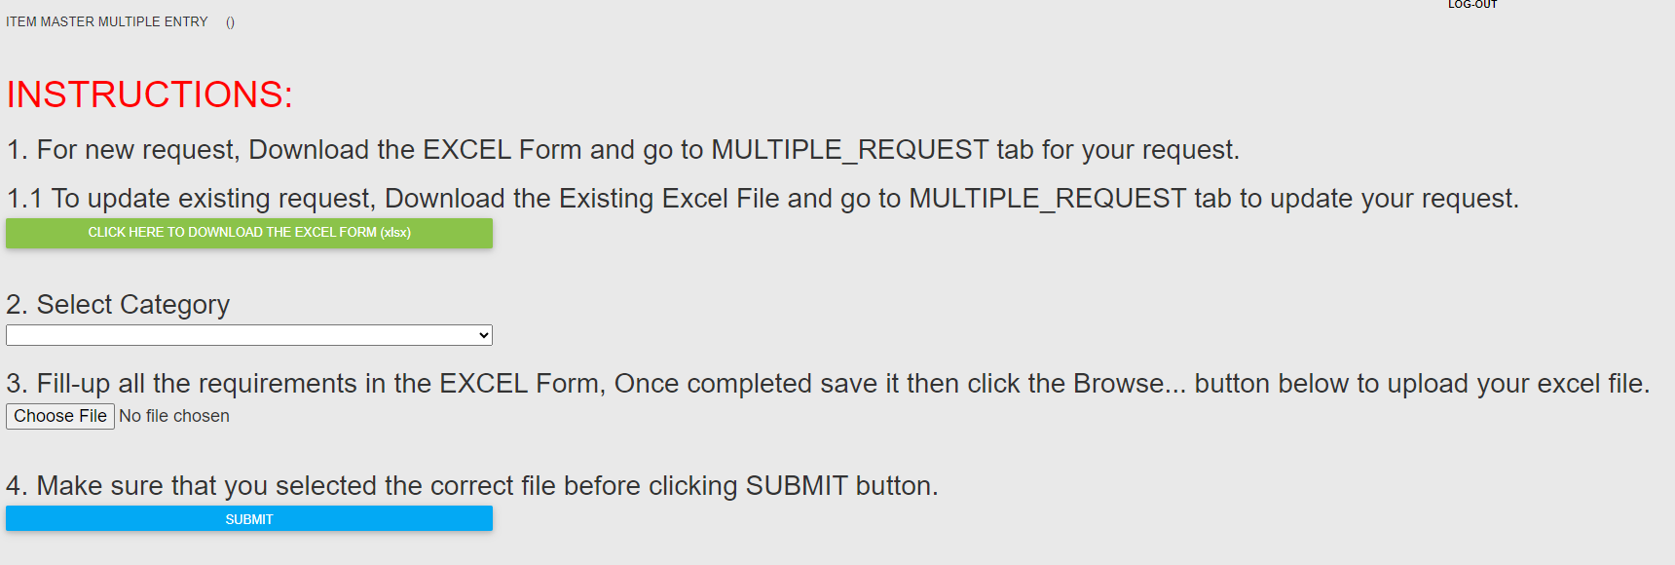

1. Transaction – Monitoring (You can view your requests status by opening Transaction Monitoring)

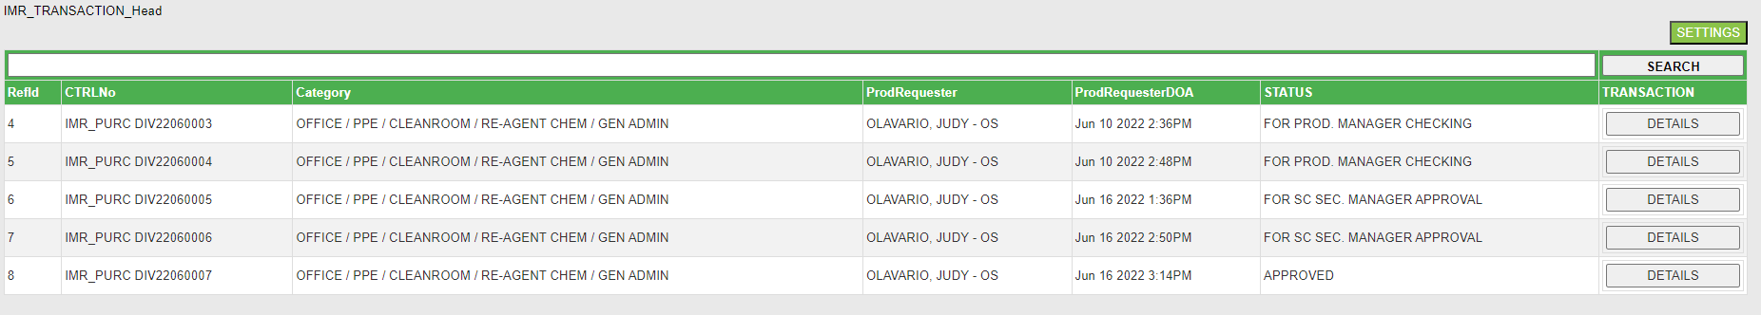

You can click the details button to check the request full details

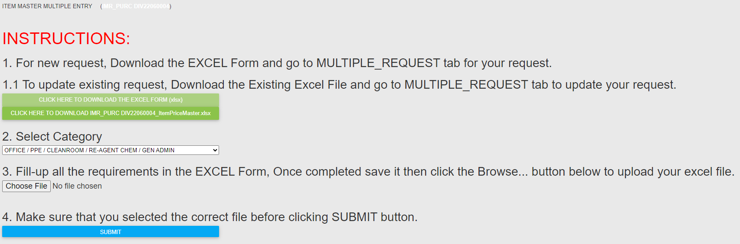

1. Transaction – Transaction Approval (This is where the SC approvers will go and check their items for approval)

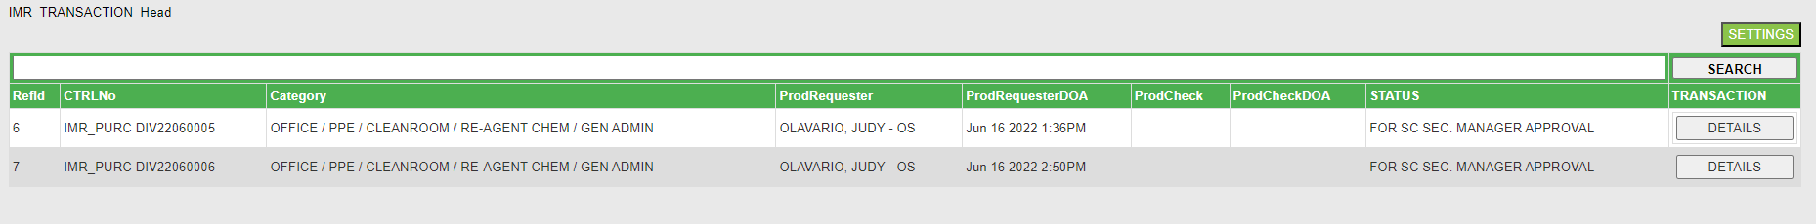

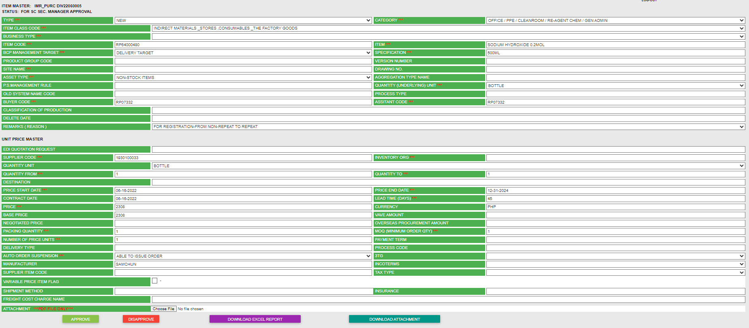

This form also offer to download the spreadsheet report and requestor attachment.

1. Transaction – All Request (This form displays all requester requests)

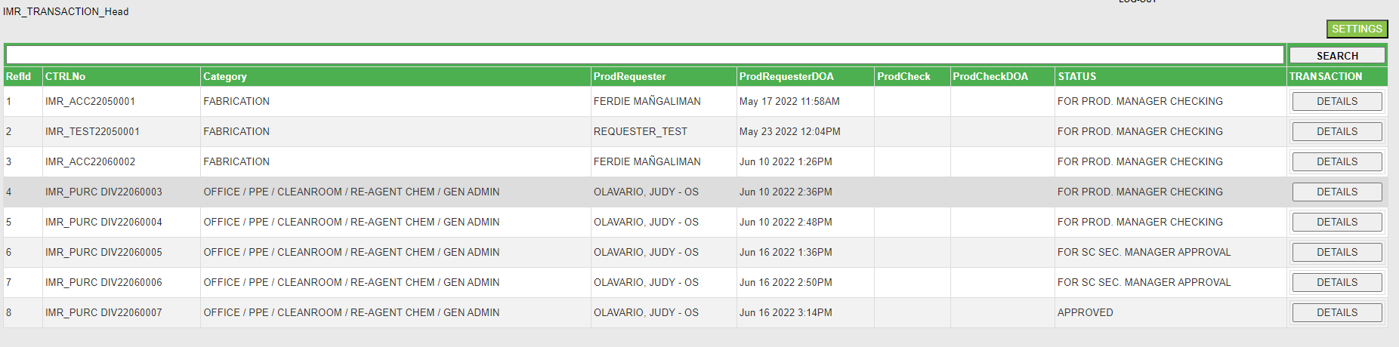

1. Transaction – Generate Item List (This form generate items list based on type; DELETE, UPDATE or NEW REGISTRATION) Follow the instructions on how to generate the item list)

